

SIMATS ENGINEERING

Saveetha Institute of Medical and Technical Sciences
Chennai- 602105

Student Name:A.Sathwika Reddy Reg. No.: 192525274
Course Code: CSA0619 Slot:D
Course Name : Design and Analysis of Algorithms
Course Faculty: Dr F. Mary Harin Fernandez

CO2_ASSESMENT TOOL 2
Aim :To implement the brute-force string matching algorithm for searching a pattern inside a document and analyze its performance.

Algorithm
- Read the text (document) and the pattern.
- Let n be the length of the text and m be the length of the pattern.
- Start comparing the pattern from the first position of the text.
- Compare each character of the pattern with the corresponding character in the text.
- If all characters match, report the pattern as found at that position.
- If a mismatch occurs, shift the pattern by one position to the right.
- Repeat the comparison until all possible positions in the text are checked.
- If no match is found after all comparisons, report that the pattern is not present.

OUTPUT:
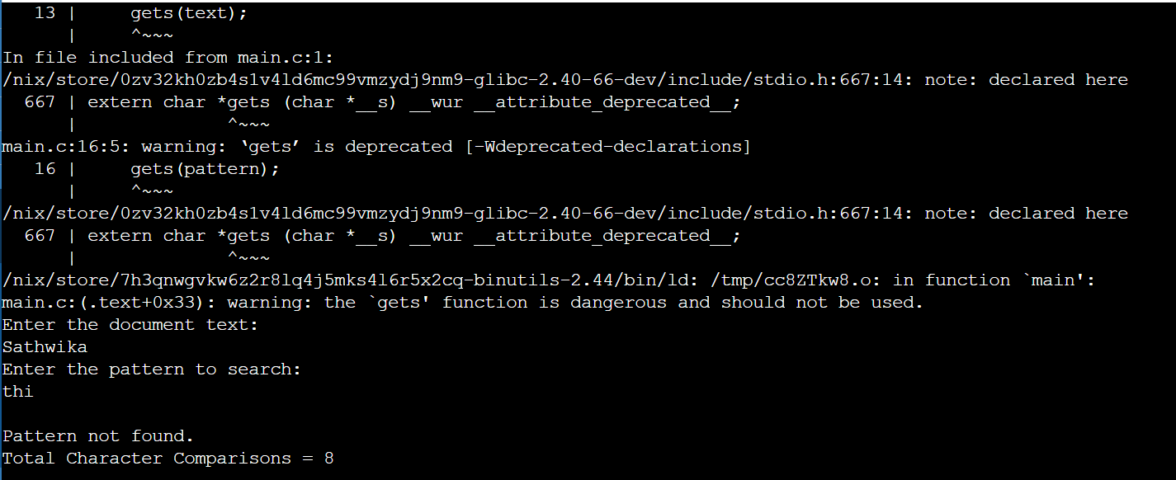

Analysis
- Algorithm Used: Brute Force String Matching
- Best Case Time Complexity: O(n) (Mismatch occurs at the first character of each comparison.)
- Worst Case Time Complexity: O(n × m) (Every character of the pattern is compared at every possible position.)
- Average Case Time Complexity: O(n × m)
- Space Complexity: O(1) (Uses only a few extra variables.)

Result:
The brute-force string matching algorithm successfully searches for the given pattern by comparing it with every possible position in the document. It correctly identifies whether the pattern exists and reports its location if found. Although the algorithm guarantees accurate results, its worst-case time complexity of O(n × m) makes it inefficient for very large documents where the pattern appears rarely. Hence, more efficient algorithms such as Knuth-Morris-Pratt (KMP) or Boyer-Moore are preferred for practical plagiarism detection systems.

